Blocking cookies might prevent some webpages from displaying correctly. To enable cookies on your machine, follow the instructions below.

Enabling cookies in Internet Explorer
- Open Internet Explorer by clicking the Start button , and then clicking Internet Explorer.
- Click the Tools button, and then click Internet Options.
- Click the Privacy tab, and then, under Settings, move the slider to the bottom to allow all cookies, and then click OK.
Blocking cookies might prevent some webpages from displaying correctly.

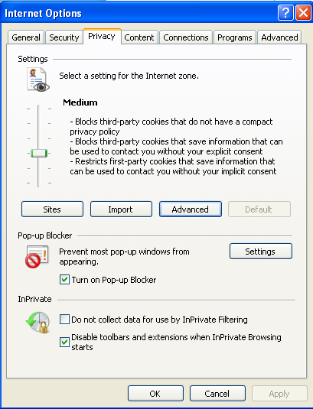

Enabling cookies in Firefox
To check or change your settings:
- At the top of the Firefox window, click on the Firefox button (Tools menu in Windows XP) and then click Options.
- Select the Privacy panel.
- Set Firefox will: to Use custom settings for history. 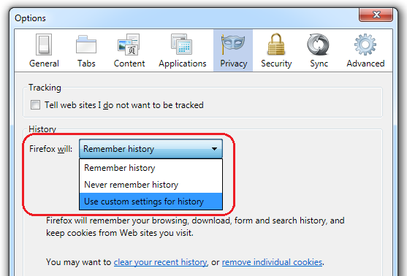
- Check mark Accept cookies from sites to enable Cookies, and uncheck it to disable them.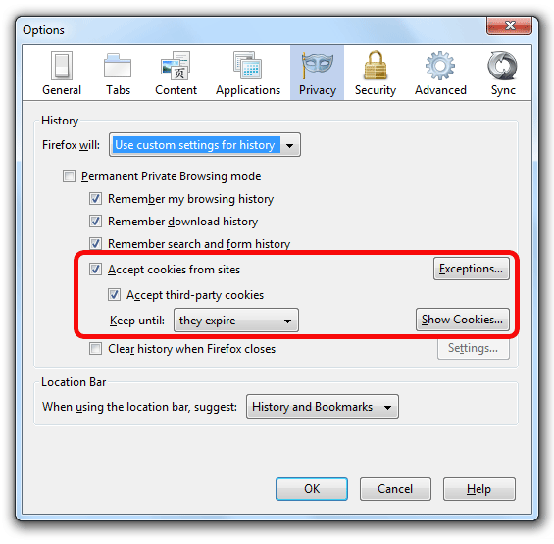
  - If you are troubleshooting problems with cookies, make sure Accept third party cookies is also check marked.
- Choose how long cookies are allowed to be stored:
  - Keep until: they expire: Each cookie will be removed when it reaches its expiration date, which is set by the site that sent the cookie.
  - Keep until: I close Firefox: The cookies that are stored on your computer will be removed when Firefox is closed.
  - Keep until: ask me every time: Displays an alert every time a website tries to send a cookie, and asks you whether or not you want to store it.
- Click OK to close the Options window.

